Early Human Migration Map
Name: ________________________________ Hour: ___________
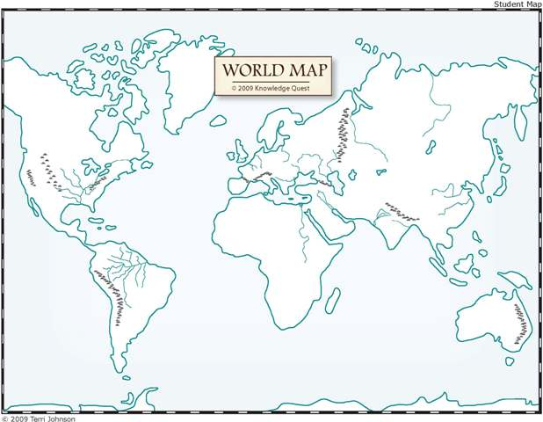
Fill in the map below with arrows that show where early humans migrated and give approximate times for when this migration took place. Once you have labeled your map answer the questions on the back of the page.

Do you think it matters that you have exact dates on your map? Why, or why not?
_____________________________________________________________________________________
_____________________________________________________________________________________
_____________________________________________________________________________________

What factors allowed migration to take place? _______________________________________________
_____________________________________________________________________________________
_____________________________________________________________________________________
_____________________________________________________________________________________
_____________________________________________________________________________________
Why did it take so long for people to reach South America? ____________________________________
_____________________________________________________________________________________
_____________________________________________________________________________________
Look at the picture of the bone dwelling on page 39. What stands out to you in terms of the structure? How have your perceptions of prehistoric people changed? ____________________________________
_____________________________________________________________________________________
_____________________________________________________________________________________
_____________________________________________________________________________________
_____________________________________________________________________________________
What area do you think would be the best for migration? Why? ________________________________
_____________________________________________________________________________________
_____________________________________________________________________________________
_____________________________________________________________________________________
_____________________________________________________________________________________

