Name/Hr _____________________________________
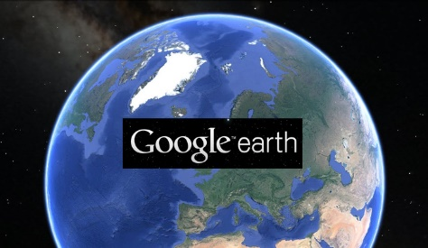
GOOGLE Earth Scavenger Hunt – Absolute Location
1. Open Google Earth from the start menu. Click View – Grid and click Off layers.
2. Fly to your house (full address: ex: 123 Main, Rochester [Hills?], MI 48309).
3. Fly from your house to school (500 Old Perch, Rochester Hills, MI 48309).
4. Type in the coordinates below and tell me what you see, and a question that you have because of the location you are at
A. 51.1789° N, 1.8262° W What do you see? _________________________________
What question do you have? ________________________________________________
________________________________________________________________________
Where are you? __________________________________________________________
B. 37.9715° N, 23.7267° E What do you see? _________________________________
What question do you have? ________________________________________________
________________________________________________________________________
Where are you? __________________________________________________________
C. 29.9792° N, 31.1342° E What do you see? _________________________________
What question do you have? ________________________________________________
________________________________________________________________________
Where are you? __________________________________________________________
D. 40.4319° N, 116.5704° E What do you see? _________________________________
What question do you have? ________________________________________________
________________________________________________________________________
Where are you? __________________________________________________________

E. 41.8902° N, 12.4922° E What do you see? ________________________________
What question do you have? ________________________________________________
________________________________________________________________________
Where are you? __________________________________________________________

5. Choose 3 locations that you are interested in studying and write their coordinates (round to the hundredth place)
A. ______________________________ ______________________________
Why did you choose this location? ___________________________________________
________________________________________________________________________
B. ______________________________ ______________________________
Why did you choose this location? ___________________________________________
________________________________________________________________________
C. ______________________________ ______________________________
Why did you choose this location? ___________________________________________
________________________________________________________________________
Go to the following coordinates: 34.5338° N, 43.4837° E. What is the area being shown? Why do you think civilization started in this region? _______________________________________
____________________________________________________________________________
____________________________________________________________________________
____________________________________________________________________________
____________________________________________________________________________
Go to the following coordinates: 29°00'00"N and 71°00'00"E. Do you think that this area would be a good one to start a civilization? Why, or why not? _________________________________
______________________________________________________________________________
______________________________________________________________________________
______________________________________________________________________________
______________________________________________________________________________

